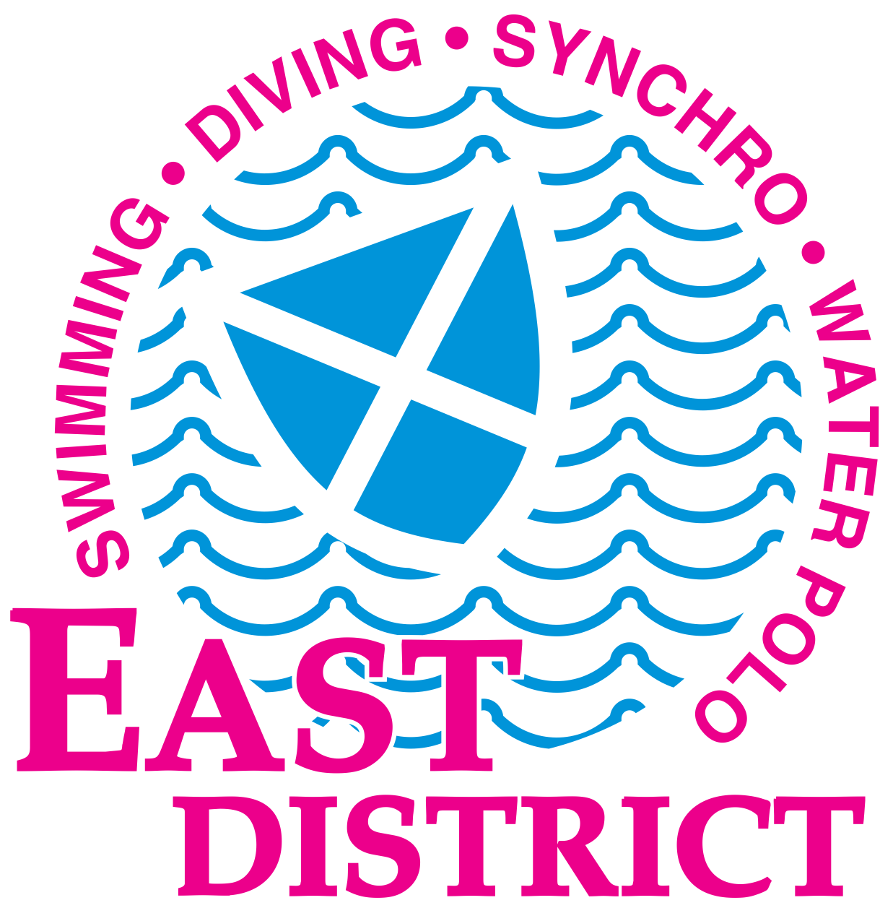 | EDINBURGH INTERNATIONAL 2020  COACH PASS REQUEST FORM

Coach and team manager passes will be available to collect at the pool from 16:00 on 12 March onwards.

To obtain passes, please complete and return this form by 8 March 2020 to tickets@eism.org.uk

Club/ Team : …………………………………………………………………………...…………… …

Contact name: ………………………………………………………………………………………………

Team manager/ coaches’ name(s) attending EISM2020:

……………………………………………………………………………………………………………………

……………………………………………………………………………………………………………………

……………………………………………………………………………………………………………………

Please confirm that all coaches and team managers for whom a pass is requested have been approved to work poolside by the appropriate swimming governing body.

Signed: ………………………………………………………………

Position in club/team ……………….. Date ………………………….

In addition, coaches from countries outside Great Britain and Northern Ireland should ask their sport governing body to provide a letter which they bring to the meet stating that they have conformed with their home countrys’ policy concerning child protection.

NOTE; Scottish coaches with a Scottish national or district coaches’ pass do not need to complete and submit this form.

