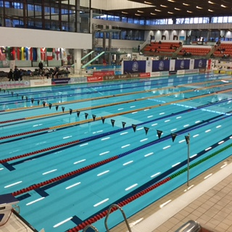

**Edinburgh International 2017**

**Event Handbook**



**Contents**

**Venue information Page 2**

**Layout of pool area**

**Venue location**

**Opening times**

**General information Page 3**

**Confirmed session times**

**Event team**

**Sponsors**

**Invited guests**

**Awards and prize money**

**Photography**

**Media**

**Transport and parking arrangements**

**Event regulations**

**Spectators**

**Information for visiting teams Page 7**

**Coaches’ information and athlete passes**

**Pool access and training on Thursday**

**Warm ups**

**Changing facilities**

**Accommodation**

**Car parking during competition**

**Catering**

**Other**

**Information for officials and event team Page 10**

**Car parking**

**Accommodation and catering Officials’ expenses**

**Clothing**

**Briefings**

**Changing facilities**



**Venue location**



The venue is located south of Edinburgh’s Old Town, close to Cameron Toll Shopping Centre and Pollock Halls of Residence (University of Edinburgh Campus). Details are:

Royal Commonwealth Pool,

Dalkeith Road,

Edinburgh,

EH16 5BB

Telephone: 0131 270 9300 Contact: Brian King/Duty Manager

**Opening times**

The event team will be able to access the venue for set up from 6:00am each day (6:15 on Sunday). Athletes and coaches should arrive from 6:45am onwards.

The pool café will be open from 7:00 on Friday until 18:00 during the competition and from 7:30 on Sunday.

**GENERAL INFORMATION - Confirmed session times**

|  |  |  |  |
| --- | --- | --- | --- |
|  | Friday | Saturday | Sunday |
| **Morning** | **Session 1** | **Session 3** | **Session 5** |
| Fastest heats  Warm up | 7:30 | 7:30 | 7:30 |
| Swimming starts | 8:45 | 8:45 | 8:45 |
| Slower heats  Swimming starts  Session ends | 11:15  15:00 | 11:15  15:00 | 11:15  15:00 |
|  |  |  |  |
| **Evening** | **Session 2** | **Session 4** | **Session 6** |
| Warm up | 16:00 | 16:00 | 15:30 |
| Swimming starts | 17:00 | 17:00 | 16:30 |
| Session ends | 19:15 | 19:15 | 18:30 |

Session 5 includes the fastest heat of the open ladies 1500m freestyle, at around 10:30.

**Event Team**

|  |  |  |  |
| --- | --- | --- | --- |
| Meet Director  Meet Referee  FINA Officials  STO Manager  Chief Recorder  Meet Entry Secretary  Scoreboard Presentation  Wetside Manager  Dryside Manager  Marshalling Manager  Media co-ordinator | Andra Laird  Andrew McRoberts  Helen Whittle  David Downie  Kevin Paterson  Alistair Shields  Jo Maguire  Susan Liddle  Tony Dane  Susan Waller  Carolyn Crichton  Gill Scott  Lindsay Lewis | Commercial Manager  Stewards Manager    Commentary Manager and Presentation  AOE manager  Meet Treasurer Officer  Guest Host  Lighting Contractor  Live streaming  (Swimscene)  Live results  Jury of Appeal  Facility Manager | Kathryn Johnstone  Niamh Simms  Duncan McKinnell  Ralph Payne  Jackie Lawrie  Helen Murray  John MacPhail  Stuart Johnston  [www.swimscotland.co.uk](http://www.swimscotland.co.uk)  [www.eism.org.uk](http://www.eism.org.uk) and Meet Mobile  Pam Thomson (chair)  Brian King |

**Sponsors**

The main meet sponsor is the **University of Edinburgh** – providing support to visiting teams of athletes, prize money, access to the University’s accommodation and catering facilities and pool dressing.

In addition**, Scottish Swimming** and its partners **Edinburgh Airport** and **Strathmore Water** have provided pool dressing, refreshments and media and press assistance. And **TYR** and **Maru** have provided kit for the officials and swim caps for youth swimmers respectively.

**Invited Guests**

A number of invited guests will be attending during the meet; they have been allocated a room directly behind the spectator seating area for refreshments. The East District will host a reception for invited guests on Sunday and Edinburgh University will do so on the Saturday evening. Guests should wear a guest pass, collected from the guest registration desk and be directed to meeting room 2, where the receptions will take place.

**Awards and prize money**

There are no medals, but cash prizes for the top two placings in each event and for first place in the youth events. Prize money should be collected from the treasurer in the meet office and signed for by the winner in person. The meet office is situated at the turn end of the main pool, near the diving pool.

There are cash prizes for the top five FINA points scorers based on swims throughout the meet. These awards will be presented poolside on Sunday evening at the end of the session.

**Photography**

No photography is permitted on poolside apart from previously authorised accredited media photographers/ journalists and authorised team personnel. Forms to register devices for use poolside are provided in coach packs, and extras can be obtained in the pool reception area.

Official photographer – we have a photographer to take photos at various sessions during the meet. Any individual swimmer, coach or team member who does not wish to be photographed should complete a ‘refusal of consent form’, available from the front desk in reception.

There are certain areas within the building where photographic devices or devices capable of taking a photograph may not be used **for any purpose**. Thus all such devices, including mobile phones, should not be used in the changing rooms, toilet or shower areas.

**Media**

Members of the press may be present. They should show their work identification and complete a photo permission forms if they wish to take photos. Some may have downloaded the appropriate Scottish Swimming form and completed it beforehand. Members of the press should be met at reception by one of the event team; in the first instance by Lindsay Lewis or if not available, by Helen Murray or Andra Laird. Photographers will wear coloured bibs if working poolside.

**Transport and parking arrangements**

Minibuses with permits from East District should park as directed by RCP car park staff, in the rear car park (first right, and right again after the main entrance to the RCP). There are a limited number of other spaces available in the car park areas on a first come first served basis.

In addition, most of the streets around the pool have restricted or pay at meter parking on **Friday and Saturday morning**. For on street car parking, this link brings you to a map which shows restrictions. Or check what it says on the parking notices in the streets. <http://www.edinburgh.gov.uk/info/20083/parking_permits/577/parking_permit_map>

Or on **Friday and Saturday,** try here :

Easi-Park; St Leonard's Street, City of Edinburgh, Edinburgh EH8 9SW – 100 space manned, uncovered car park, available all day at around £10-11 a day – payment by cash or cheque. Hourly rates available if only staying part of the day. For location and charges see: <http://en.parkopedia.co.uk/parking/near/royal-commonwealth-pool-and-sauna/>

The good news is that there are no restrictions at all on **Sunday**. Also, you can park on any day in the area shown on the attached map.

Finally beware, the Council has introduced 24hr 20mph limits across much of the city.



**RCP**



**You are here**

**Free street parking**

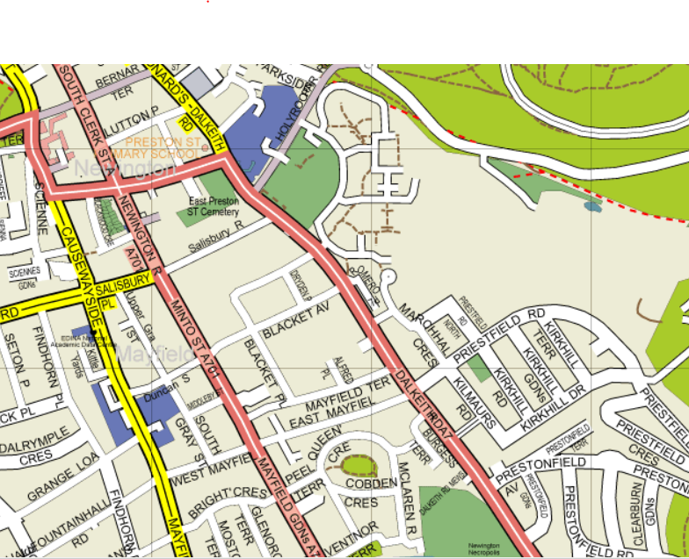

**Event regulations**

**For all**

* The meet is organized by SASA East District and licensed by Scottish Swimming.
* The stewards and officers of the East District and the facility management have discretion to ask any person with or without a valid ticket to leave the venue.
* Those at the event must at all times comply with the instructions given by any steward or officer of the East District and/or the facility management.
* The following articles must not be brought within the venue: fireworks, glass, smoke canisters, air horn, flares, weapons of any sort.

Any person with such an item will be refused entry as instructed by a steward or officer of the East District or the facility management.

* Any person wishing to use video/other photography in the spectator area or poolside must register their device at the desk in the foyer area of the pool.
* No articles, periodicals, publications, flyers, or goods of any nature may be offered either free or for sale by any persons, save only the East District, without written permission of the East District.
* Authorised personnel acting on behalf of the East District will take static photos and video footage for the purpose of future promotion of the event and for live streaming. Images will be made available to media partners, on our website and on our social network sites. Competitors not wishing to be photographed should complete a form available from the meet organiser.

For competitors and team staff

* Only accredited personnel are entitled to be in the changing village or on the pool deck.
* Swimmers should comply with the health and safety instructions in place for the meet. Swimmers may not use the gallery stairways or top corridor when wearing wet swimsuits or without appropriate footwear.
* Swimmers should use the facilities provided in the changing village. They should not change in the seating area or toilets.
* All swimmers are responsible for the care of their belongings in the pool area. There are lockers in the changing area which should be used. Large bags and clothes should not be brought into the seating area.
* Photography is not permitted in the changing rooms, showers or toilet areas. Nor should any device with a photographic capability be used in these areas.

For spectators

* Spectators may not throw objects within the venue, nor use foul or abusive language or other offensive words such as racial or sexual abuse within the venue. Alcohol may not be consumed within the venue.
* The facility management request that the following procedures are adhered to :

All spectators will vacate the spectator area in between sessions.

No standing on the balcony during the event or obstructing stair ways and

passageways.

No large bags or clothing on seats in the spectator area.

* Anything not covered above or included in the ancillary information will be at the promoter’s discretion.

**Spectators**

Spectator seating is located around the side of the pool overlooking the competition area. A number of seats for invited guests will be designated throughout the competition. Disabled/wheelchair access seating is available – speak to the dryside manager, Carolyn Crichton about requirements.

**Entrance prices** Concessions (children under 15 years and 65+)

£5 per person – heats sessions £4 per person – heats sessions

£7 per person – evening finals £6 per person – evening finals

**Programmes and start sheets**

£2 per commemorative programme

£1 start sheets (for each of heats and finals sessions)

**Photography**

Spectators are welcome to take photographs from the spectator area provided they have registered at the front desk by completing the photographic registration form and display the “neon green” wristband provided on their camera/video equipment.

**INFORMATION FOR VISITING TEAMS**

**Coaches information and athlete passes**

Coaches packs will be available for collection from the desk in the foyer area of the RCP from 16:00 – 20:30 on Thursday evening, and from East District staff in the reception area throughout the competition.

Athletes and all team personnel will need to show accreditation passes to enter the changing village and gain access to the pool area. Athlete and team staff passes will be included within the coaches packs. Coaches/team managers should consider and make an arrangement to get passes to athletes arriving while they are on the poolside.

There is a coaches meeting area behind the athlete seating in the spectator gallery, where tea, coffee and water will be available all day. A short **coaches meeting will take place in the meeting area at 19:00 on Thursday 9th.** Please send a team representative. Any not able to attend should come to the follow up meeting at **7:30 on Friday 10th**.

**Pool access and training use on Thursday**

On Thursday evening teams may, by prior arrangement, swim at the RCP, from 16:30-20:00. Please email [info@eism.org.uk](mailto:info@eism.org.uk) to request some pool space. This will be allocated on a first come first served basis.

On competition days, on entering the Royal Commonwealth Pool, all groups should go to the stairs on the left of the main reception desk. Stewards will direct each group to the staircase that takes them to the correct changing area. Passes must be shown to enter this area.

Athletes, team staff and coaches should enter the pool through the wetside changing rooms.

**Warm ups**

Warm ups each day will commence at 7:30; the main competition pool will be cleared at 8:30 for racing to start at 8:45.

The diving pool will be open throughout the day.

The teaching pool will be open until about 15:00 each day.

The competition pool will reopen for warm up / swim down after completion of the heats, no later than 15:15 each day. It will remain open until 15 minutes before the finals sessions are due to commence.

Those swimming in the later, slower heats should make use of the diving pool and teaching pool for warm ups. Swimmers and coaches are expected to use these pools appropriately and respect the needs of other users.

**Changing facilities**

Changing should take place in the designated areas and not on poolside or in the toilet areas. Clothes should be stored in lockers for which a returnable £1 coin is required.

**Accommodation**

Athletes, team staff and coaches’ accommodation booked through the East District is at one of the following locations, as confirmed by email:

**Masson House**, Pollock Halls, Holyrood Park, Edinburgh EH16 5AY. Check in 14:00, check out 10:30am. Tel 0131 651 2198. Reception at Masson House on the Pollock Halls campus

**Salisbury Green Hotel**, Pollock Halls, Holyrood Park, Edinburgh EH16 5AY. Check in 14:00, check out 10:30am. Tel 0131 651 2198. Reception is at Masson House on the Pollock Halls campus

**Richmond Apartments** 5-9 Richmond Place, Edinburgh, EH8 9VE. Check in 14:00, check out 10:30am. Tel 0131 545 2245. Reception is at Kenneth McKenzie House (7 Richmond Street) .

**Car parking during the competition**

Teams that have booked accommodation at Masson, Salisbury or Richmond through the East District should send details of car / minibus registration numbers beforehand, by 5 March, to [info@eism.org.uk](mailto:info@eism.org.uk) to book a parking space in the University grounds at Pollock Halls – it is a very short walk from there to the pool. You may leave cars at Pollock Halls overnight.

**Catering**

**Breakfast** is available at Masson House from 6:30am each day throughout the competition (and 7:30 on other days ie Thursday and Monday). Salisbury Green residents should use the dining room at Masson House which is beside their accommodation. Guests are advised to confirm their breakfast arrangements with the venue when they arrive.

**Team staff meals at RCP**; Some team staff have requested tickets to eat at the pool during the day. These meals will be served in Studio 3 (exit through the door behind the recorders desk); the tickets for these will be included in the coaches’ packs. Soup, roll and light snacks are available from 11:00-14;00. Main meals will be served at 15:00.

**JMCC lunches/dinners**; All other hot/cold meals requested by athletes and team staff are served at JMC centre on the Pollock Halls campus. The correct number of meal tickets for each day will be included in the coaches’ pack of information set aside for each team. A ticket must be presented by any individual wanting access to the dining area at JMCC.

Meal times at JMC centre are as follows:

**Lunch**

Thursday 13:00 – 14:00

Friday 12:00 – 14:30*

Saturday – Sunday brunch 10:30 – 14:30*

**Dinner**

Wednesday, Thursday and Sunday 17:00 – 19:30*

Friday and Saturday 17:00 – 20:00*

* doors close; 30 mins to complete meals

Wednesday lunch by arrangement.

**Packed lunches**; these can be collected on a daily basis from JMCC from about 8:00 onwards. Or we can arrange to bring them up to the pool area for teams if they so wish – speak to the front desk at reception who will put you in touch with one of the drivers to do this.

**Other**

**Doping control** – testers are on site each day of the competition. For further information speak to the wetside manager, Susan Waller.

**Groceries** - There is a Sainsbury’s supermarket at the Cameron Toll Shopping Centre and on the corner of South Clerk Street / Bernard Street, 2 blocks from the pool.

**Medical** – In the event of an accident/emergency the venue staff will deal with any first aid incidents. An accident form (available from the front desk) must be filled in if any incidents occur. Carolyn Crichton (Dryside Manager) must sign all accident report forms.

**Nearest Hospital** – Edinburgh Royal Infirmary, Old Dalkeith Road, Edinburgh, EH16 4SA. Emergencies - 999

**INFORMATION FOR OFFICIALS AND EVENT TEAM**

**Car parking**

Where possible officials and event staff are asked to park off site at Peffermill and use the shuttle buses. The site is located at University of Edinburgh National Hockey Academy, 42 Peffermill Road Edinburgh EH16 5LL. Contact Alistair Shields for further information saseastdistrictsto@gmail.com

**Accommodation and catering**

Requested accommodation for event staff has been booked. An emailed confirmation has been sent to those for whom accommodation is arranged setting out details and dinner and breakfast arrangements. Any queries please contact Andra Laird, [andra.laird@eism.org.uk](mailto:andra.laird@eism.org.uk)

Refreshments, lunch and snacks will be available throughout the day in Studio 3 at the RCP.

**Officials’ expenses**

Expense claim forms are available from Morag Taylor from the front desk and Alistair Shields. Expenses incurred during the event can be reclaimed on completion of your expenses form (including receipts).

**Clothing**

East District staff should wear their blue district shirts with dark blue or black trousers (not denim).

Stewards will be provided with blue tops from the East District. These should be teamed with appropriate dark blue or black full length or three-quarter length trousers.

Officials will be issued with event shirts to wear at all sessions. We have a limited number and those attending all three days may need to reuse shirts on later sessions. Officials should team these shirts with their own full length white trousers/knee length skirt and shoes/sandals for the event. This clothing should generally be unbranded and not conflict with our event sponsors.

**Briefings**

Technical officer and steward briefings will take place before each session in the Officials Room.

**Changing Facilities**

Officials and volunteers can use the dryside changing village. All belongings should be stored in the lockers provided and not left in the Officials’ Room. Lockers are available for a £1 deposit.